- Write a Python script that generates 1000 random numbers following a normal distribution with mean 500 and standard deviation 100, then plot the resulting distribution using matplotlib.
ANSWERS:
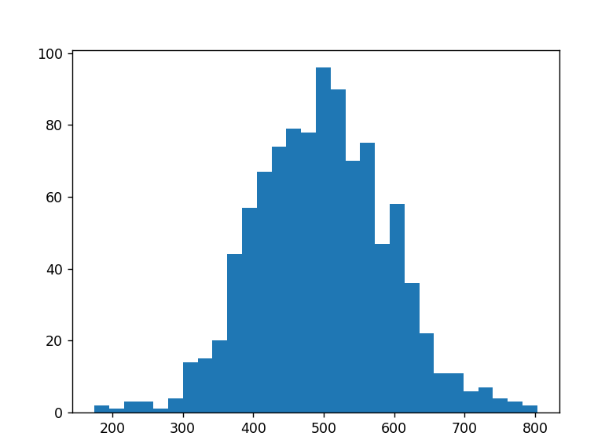
- Given an array of daily step counts from a fitness app, calculate the Z-score for a specific day where the user walked 9500 steps. Assume the mean is 8000 and standard deviation is 1200.

Hint: Use the formula Z = (X - μ) / σ.
ANSWERS:
Z = (9500 - 8000) / 1200

- Plot a standard normal curve (mean 0, standard deviation 1) using matplotlib, and shade the area between Z = -1 and Z = 1 to visualize the probability of values within one standard deviation.
ANSWERS:

4.) You are analyzing the delivery times (in minutes) for a food delivery app like Zomato. Given a normal distribution with mean 30 and standard deviation 5, write code to find the probability that a randomly selected delivery takes less than 25 minutes.
Hint: Use scipy.stats.norm.cdf()
ANSWERS:
=NORM.DIST(25,30,5,1)
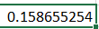

- Use ChatGPT to explain in your own words why the normal distribution is important for analyzing real-world app data like sales, delivery times, or user ratings. Paste your prompt and the AI's answer in your submission.
ANSWERS:
The normal distribution is important because many real-world data values are close to the average, while very high or very low values happen less often.
For example, in apps like Swiggy or Zomato, most delivery times are around the average time. This helps companies understand customer behaviorssss, find unusual values, and make better business decisions.

